GOVERNMENT OF THE DISTRICT OF COLUMBIA
EXECUTIVE OFFICE OF THE MAYOR

Mayor’s Office of Legal Counsel

June 2, 2023

Anita Bonds
At-Large Councilmember
Chairperson, Committee on Executive
Administration and Labor
1350 Pennsylvania Ave., NW, Suite 404
Washington, D.C. 20004

Re: Follow-up to MOLC Fiscal Year 2024 Budget Oversight Hearing

Dear Madam Chair,

Please accept this correspondence as a supplement to my testimony presented to you at the Fiscal Year 2024 Budget Oversight Hearing on behalf of the Mayor’s Office of Legal Counsel (“MOLC”).

At the hearing, you requested the available numerical data related to the Freedom of Information
Act (“FOIA”) appeals received and processed by the MOLC throughout the fiscal year for the purpose of assessing the office’s current staffing needs and for consideration in any future efforts by the Council to modernize the District’s FOIA statute. While we do not currently maintain all of the statistics discussed, the available data speaks to your concerns, and we will revisit the collection of additional data that may assist future efforts to reform and improve public accessibility to District records.

One of the challenges experienced by the MOLC during the public health emergency was an increase in unresolved FOIA appeals creating a significant backlog. This backlog originated, in part, at the agency level due to the tolling of statutory deadlines which resulted in unripe appeals and a bottleneck of outstanding FOIA requests.

Beginning in FY 22, the MOLC undertook a concerted effort to address these delinquent opinions and bring the agency into compliance with the statutory deadlines afforded by FOIA. As depicted below, significant progress has been made towards reaching this goal. To date, the MOLC has reduced the number of unresolved appeals to approximately 39.

Page 2
Chairperson Bonds
June 2, 2023

Appeals Docketed Appeals Resolved Unresolved Appeals Efficiency

FY 21 268 89 231 33.2%
FY 22 232 210 237 90.5%
FY 23 125 318 39 254.4%

Looking forward, we anticipate the number of appeals received will remain steady as well as our efficiency in resolving them.

Regarding the two cases that council witness, Mr. Fritz Mulhauser, mentioned at the Budget Oversight Hearing, we previously advised you as to the details of one of these cases in our February 24, 2023 correspondence. Quite simply, we inadvertently sent out a draft opinion which was quickly corrected. Neither, the draft nor the final opinion were ever subject to the scrutiny of the Office of the City Administrator, as suggested by Mr. Mulhauser.

The second case referenced by Mr. Mulhauser was an appeal of a FOIA determination made by the D.C. Board of Ethics and Government Accountability (“BEGA”). In the appeal of that case, BEGA declined to send the MOLC a copy of an audio recording it had made during an investigation of a complaint. In the absence of reviewing that recording, and in the consideration of BEGA’s authority to both steer and mandate the District’s FOIA policy through the issuance of advisory opinions, the MOLC deferred to the determination of BEGA not to release the audio pursuant to the exemptions cited by BEGA in response to the FOIA request. It would have been otherwise imprudent for this office to issue an opinion on records an agency declined to provide and that we did not have an opportunity to review.

I hope the foregoing addresses any concerns arising out of the MOLC’s budget oversight testimony. Please let us know if you require any further information or clarification. We appreciate your oversight of the MOLC’s work and are committed to providing you with the most accurate and up-to-date information .

Sincerely,

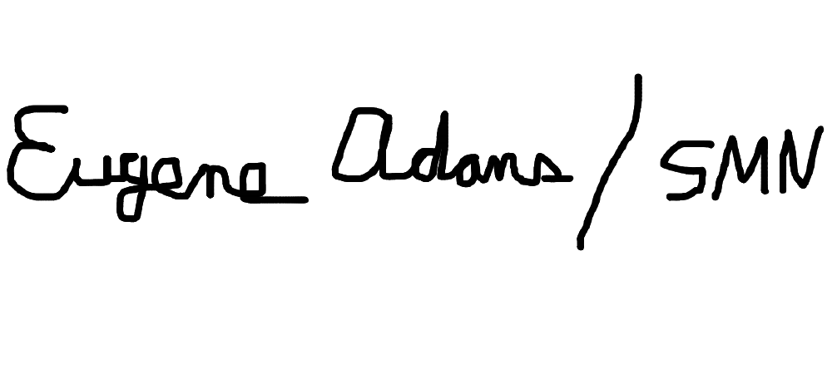
_________________________ Eugene Adams
Director, Mayor’s Office of Legal Counsel
1350 Pennsylvania Avenue NW, Suite 407
Washington, D.C. 20004

At the end of the fiscal year; to date, for FY 2023.
The number of yearly opinions completed divided by the number received (Appeals resolved/Appeals Received).

